

**Software Requirement Specification**

**On Demand Tutor System (ODTS)**

**Version: 1.0**

– HCM, May - 2024 –

1. Data Base Diagram

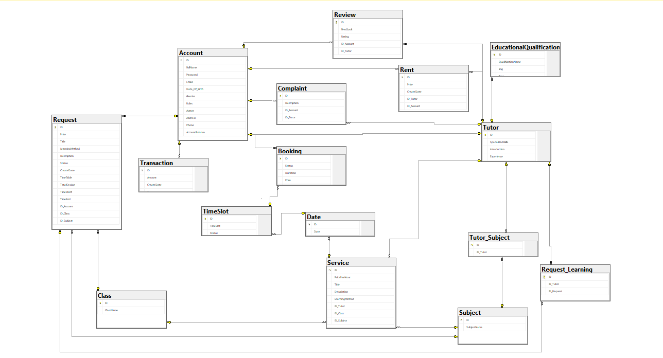

1. Funtional Requirement
2. Usecase List

Register

Login

Login by Google

Logout

Change password

Get new password

Search Subject

Search Tutor

View Rental Services

Create Request

Update Request

Delete Request

View Request

Register as a tutor

Approve Tutor

Booking Services

View contact Tutor

Edit profile

Edit profile

View Profile

Create Complaint

View Complaint

Create Feedback

View feedback

Vote Start

Confirm Tutor Profile

Confirm Request Learning

Delete Account

View information of all students

View information of all tutors

View revenue report

Delete Account

View all requests

View all rental services

Join Request

Create Service

Update service

Delete service

4.UI

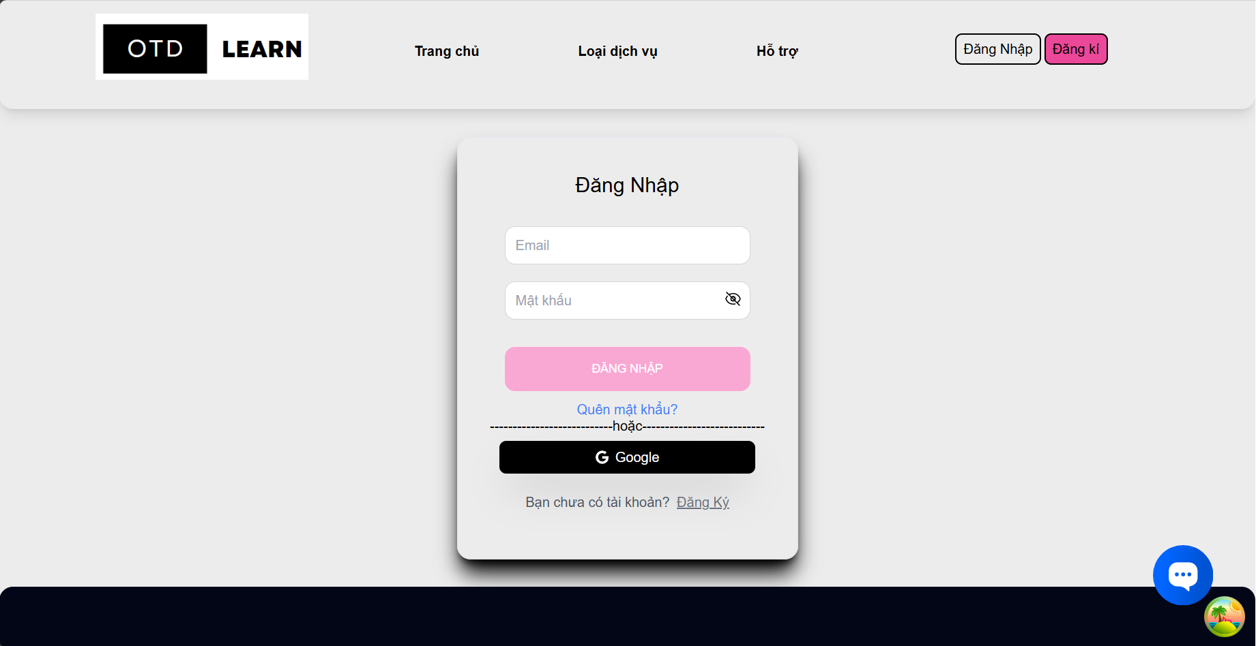

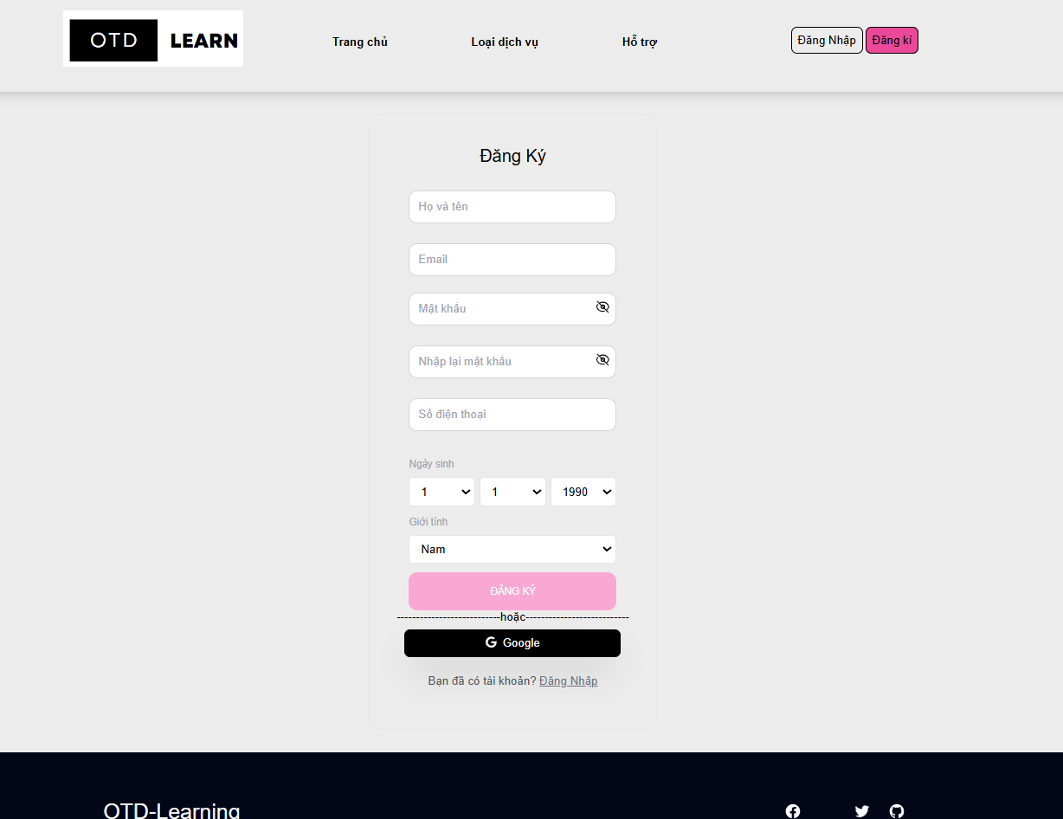

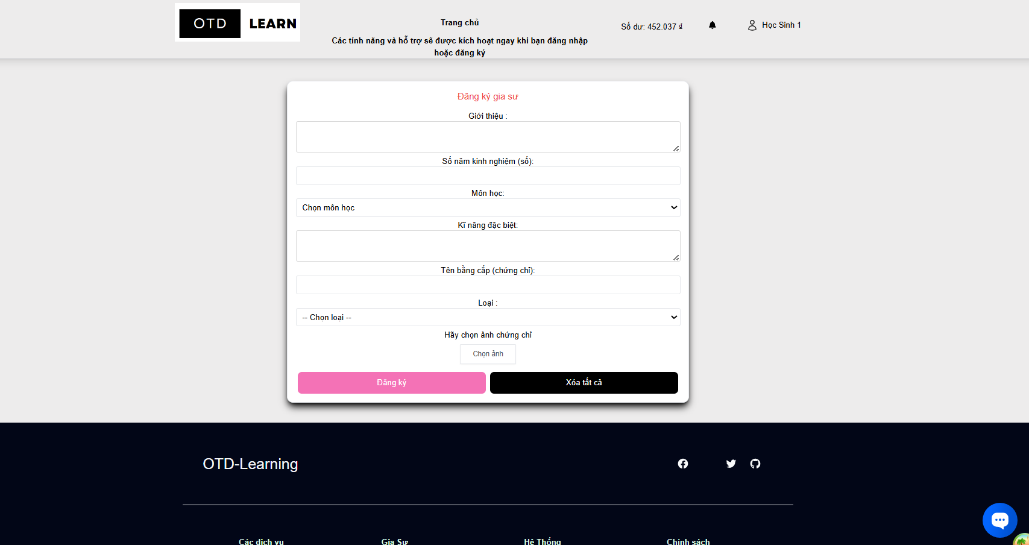

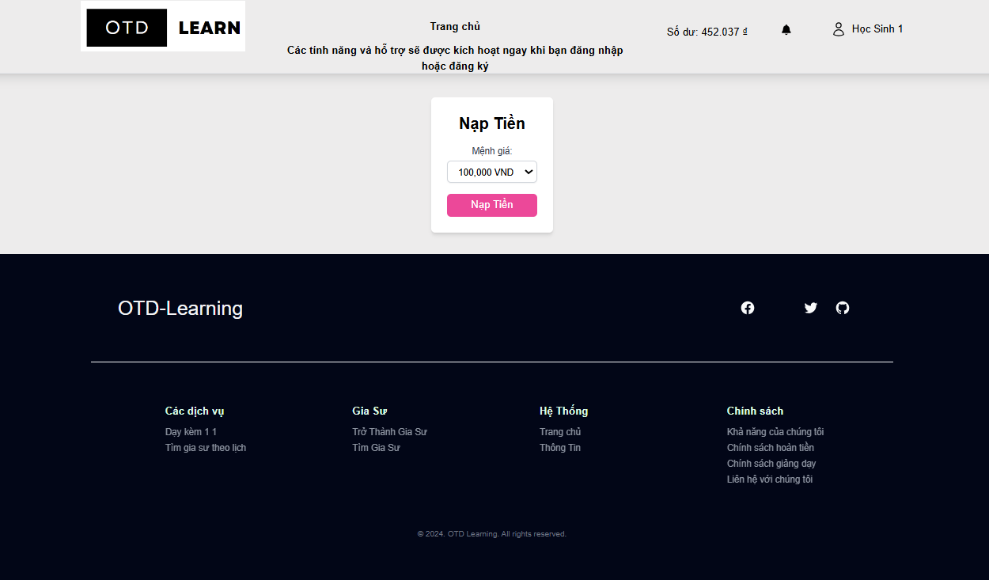

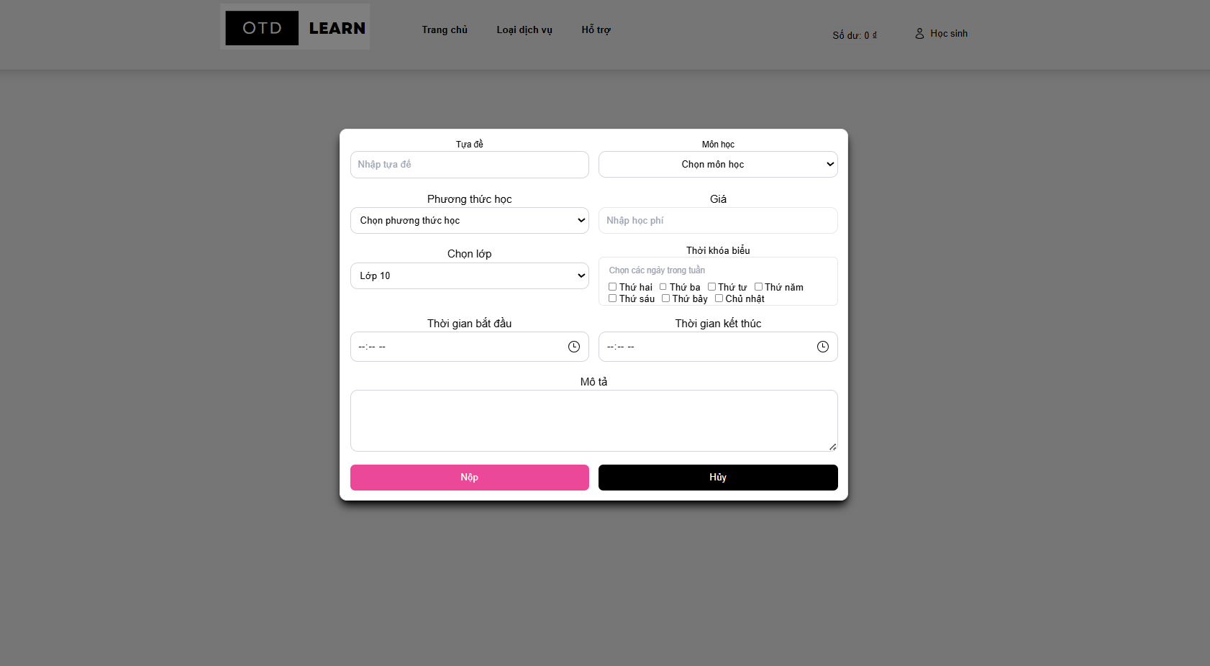

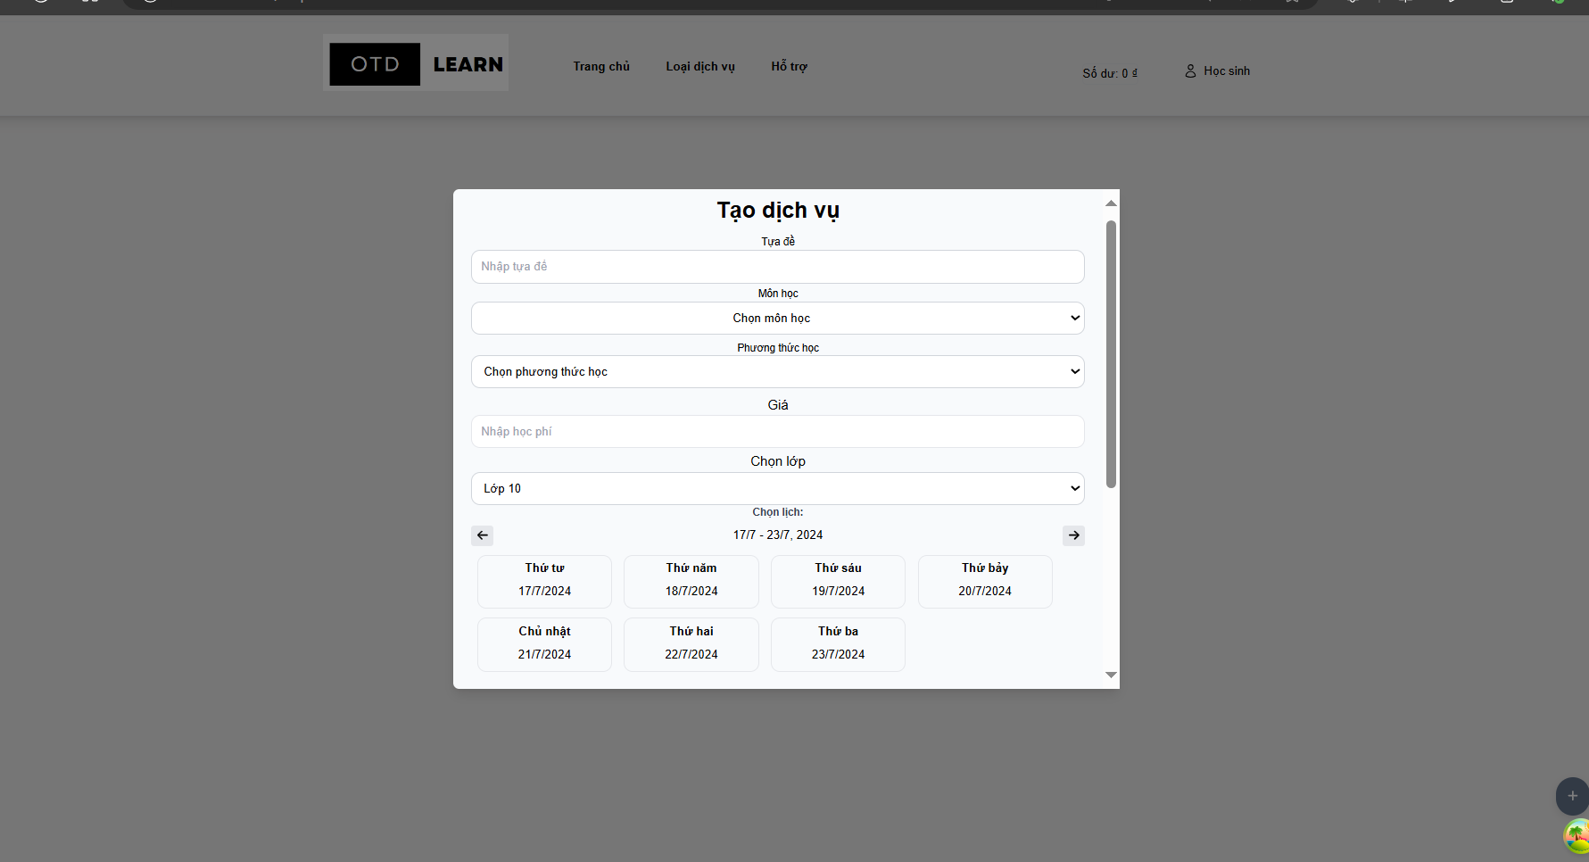

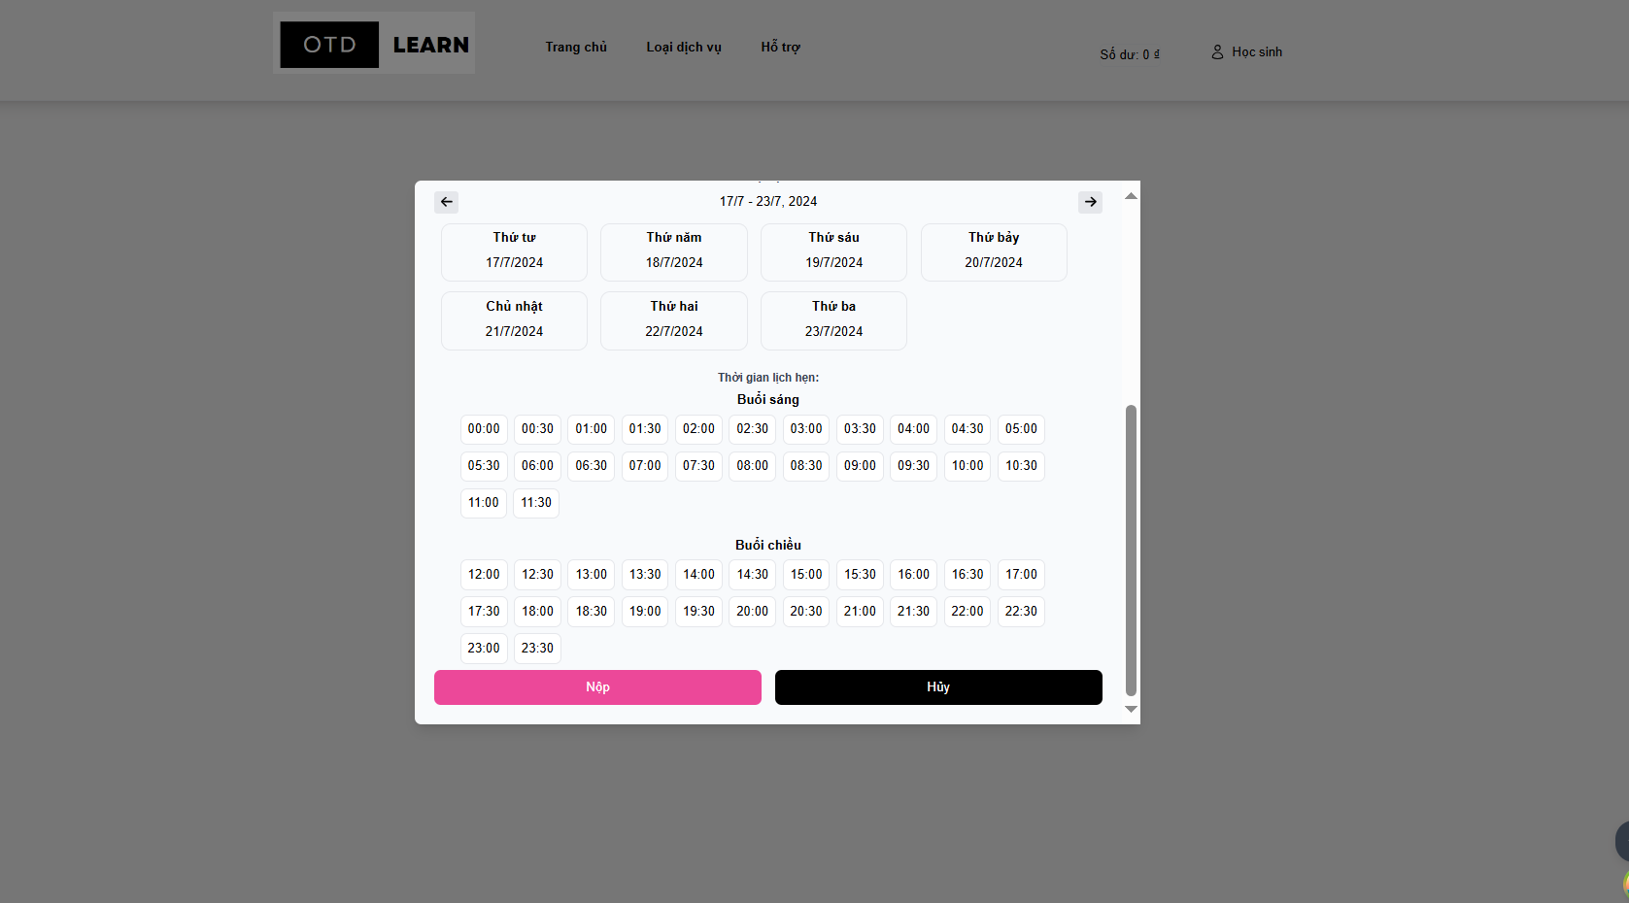

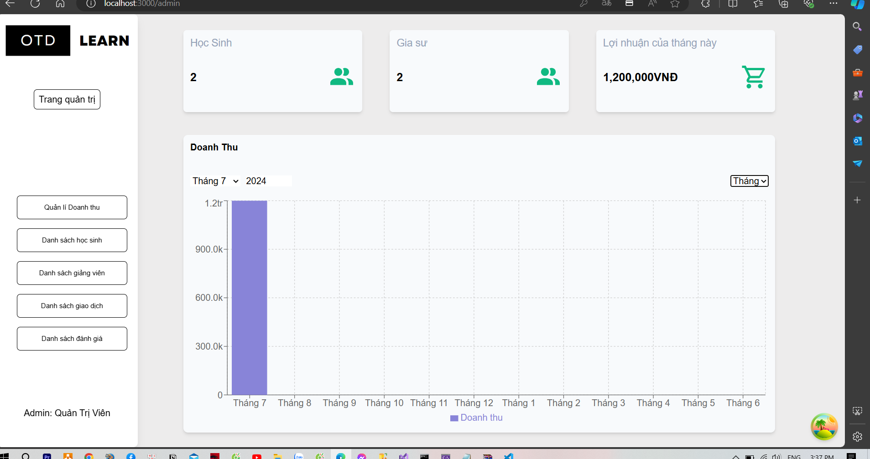

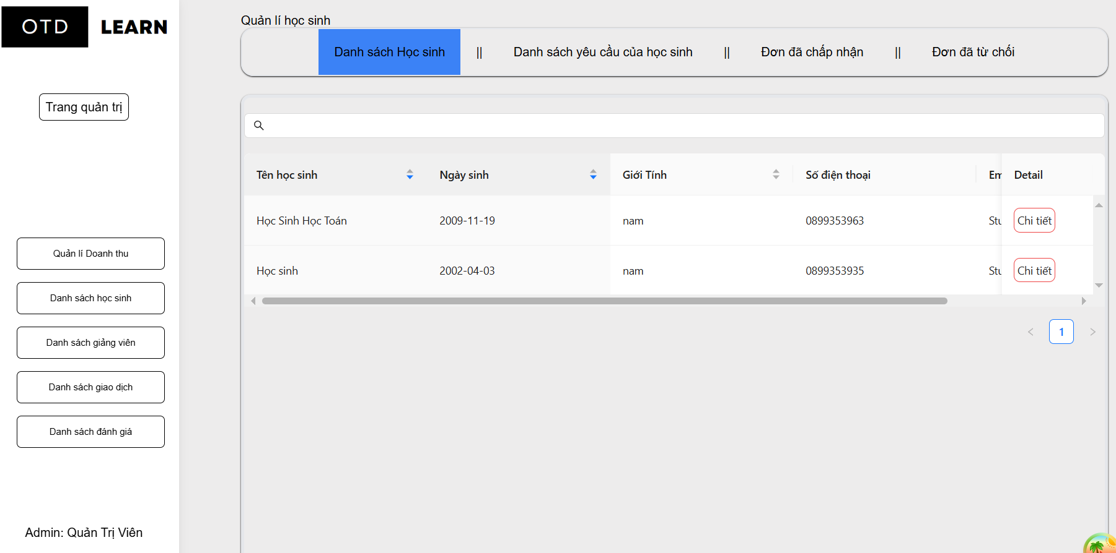

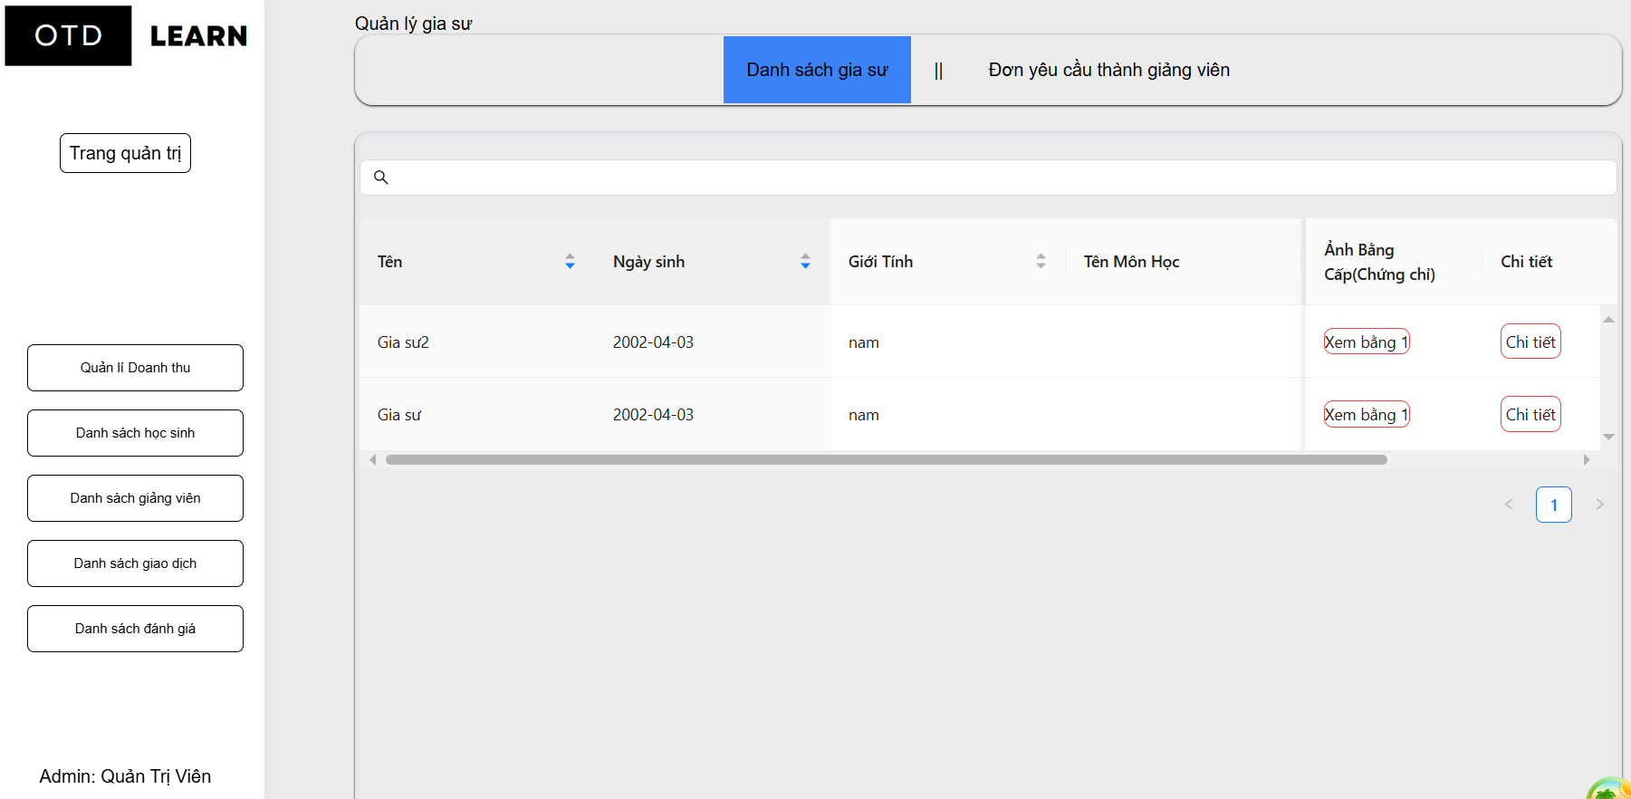

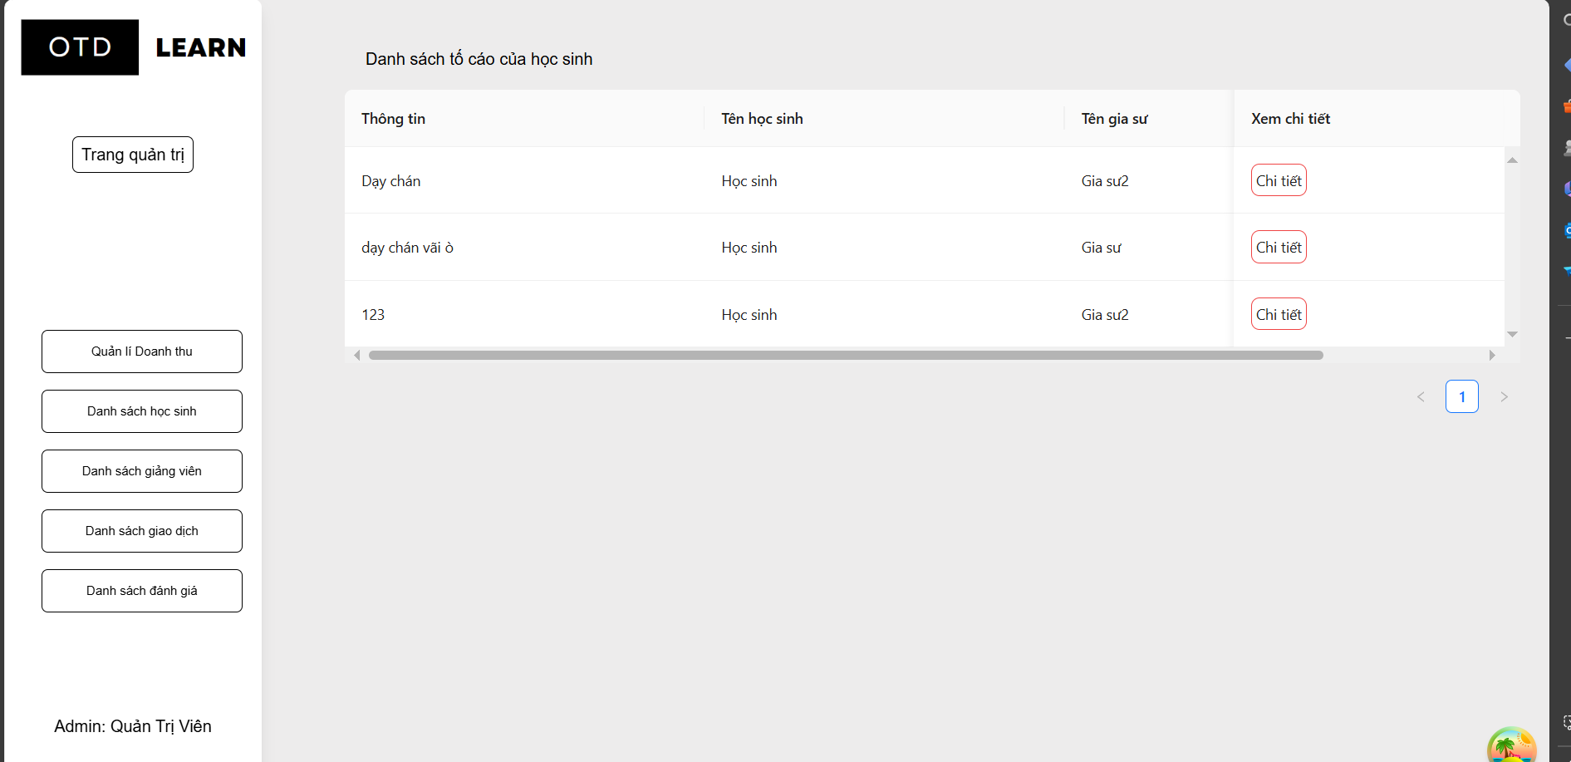

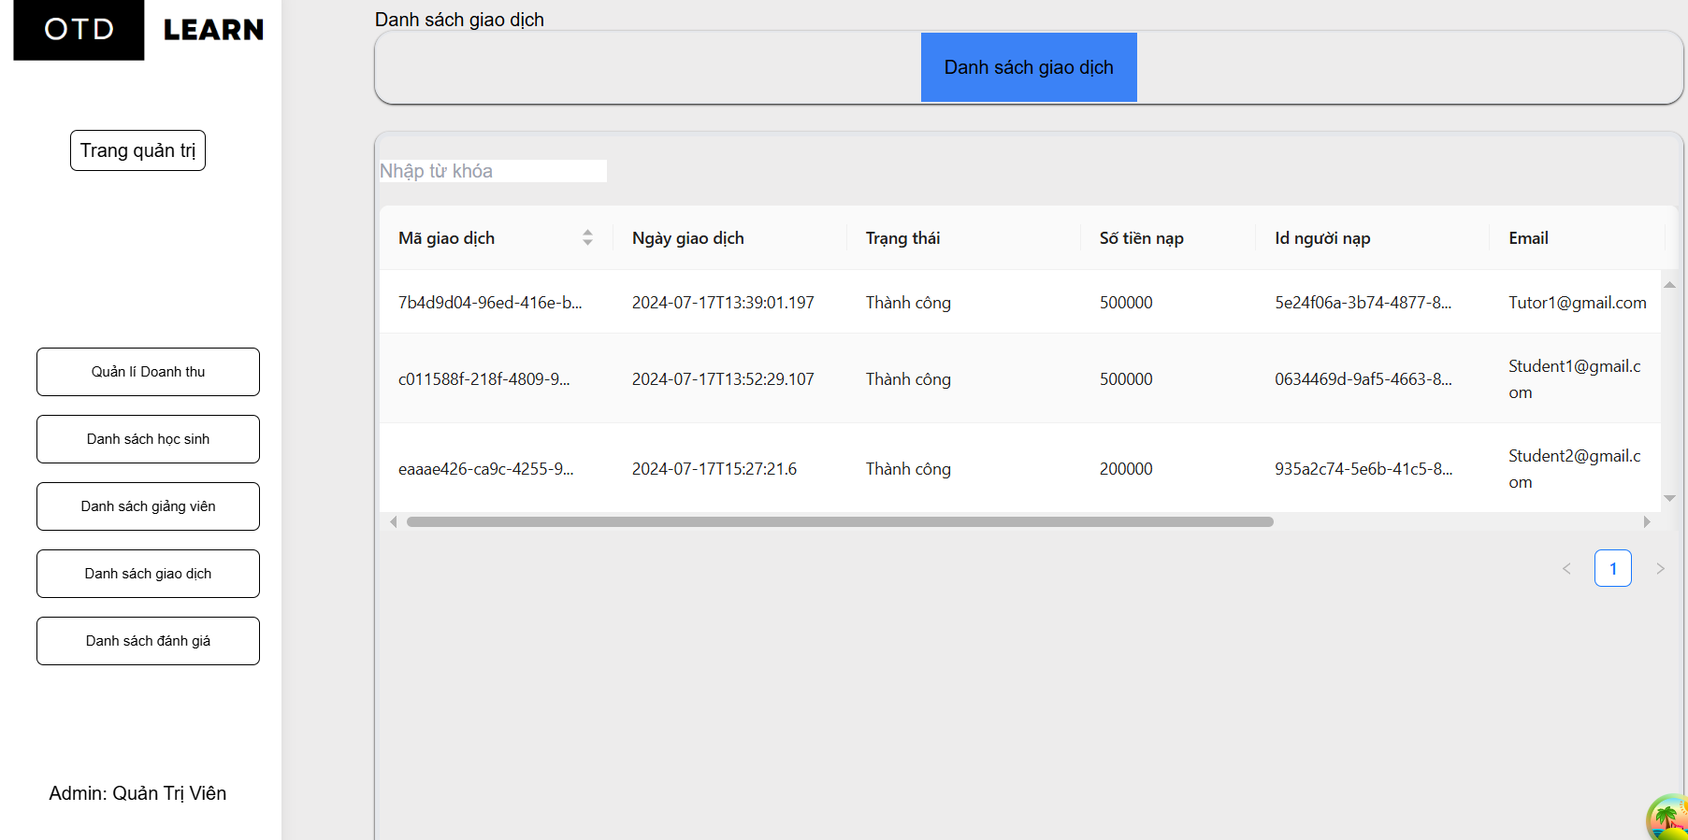

5. TECHNICAL REQUIREMENT

6. SCREEN FLOW

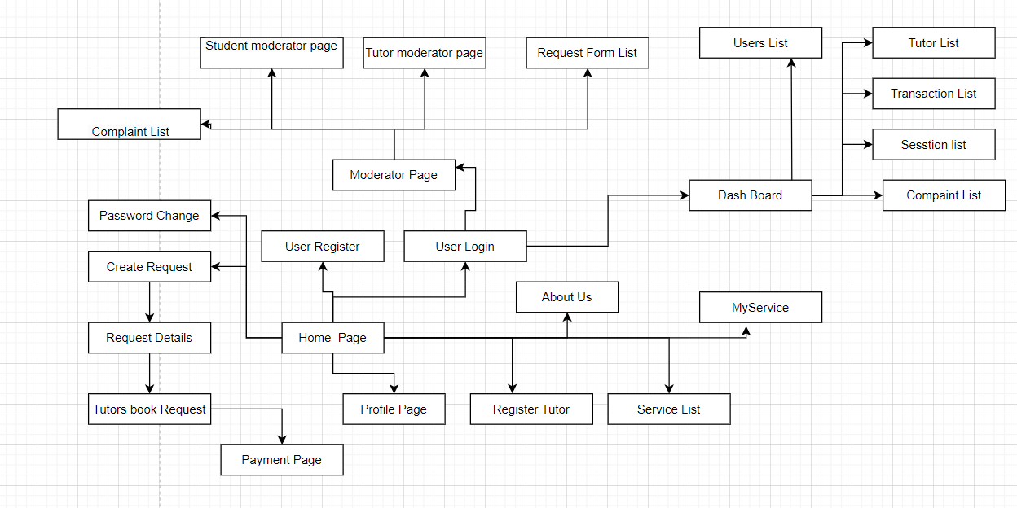

7. BUSINESS ROLE

## 

| **ID** | **Category** | **Rule Definition** |
| --- | --- | --- |
| **BR-01** | Learning Management Requirements | When a student chooses 1 tutor from many tutors who have joined their request, the system will receive 50,000 VND from the tutor's account in the system. |
| **BR-02** | Service management | When a student makes a booking for a service from a tutor, it is required to have money in the system, so the student will perform the recharge function first. |
| **BR-03** | Service management | When a student makes a booking for a service from a tutor, the system will receive 10% of the student's booking fee |
| **BR-04** | Service management | When a student makes a booking for a service from a tutor, and after the student chooses to end the class, 90% of the money from the booking will be transferred to the tutor's account. |
| **BR-05** | Tutor management | Before the tutor can perform the function of participating in the request, there must be 50,000 VND in the tutor's account. |

## 